**Day 3 Lab Manual Part 2**

**BIVARIATEANALYSIS IN R -COVARIANCE, CORRELATION,**

**CROSSTAB**

**S.Dhanush kumar**

**192121154**

**Exercise: 8**

**Reference Status Gender TestNewOrFollowUp**

**1 KRXH Accepted Female Test1 New**

**2 KRPT Accepted Male Test1 New**

**3 FHRA Rejected Male Test2 New**

**4 CZKK Accepted Female Test3 New**

**5 CQTN Rejected Female Test1 New**

**6 PZXW Accepted Female Test4 Follow-up**

**7 SZRZ Rejected Male Test4 New**

**8 RMZE Rejected Female Test2 New**

**9 STNX Accepted Female Test3 New**

**10 TMDW Accepted Female Test1 New**

**i) Load the dataset and Create a data frame and name it as dataframe1ii) Load the function for crosstab**

**Note: Perform status+gender**

**Gender**

**Status Female Male**

**Accepted 5 1**

**Rejected 2 2**

**Note: Reference+Status**

**Status**

**Reference Accepted Rejected**

**CQTN 0 1**

**CZKK 1 0**

**FHRA 0 1**

**KRPT 1 0**

**KRXH 1 0**

**PZXW 1 0**

**RMZE 0 1**

**STNX 1 0**

**SZRZ 0 1**

**TMDW 1 0**

**PROGRAM**

1.Reference <- c("KRXH", "KRPT", "FHRA", "CZKK", "CQTN", "PZXW",

"SZRZ", "RMZE", "STNX", "TMDW")

Status <- c("Accepted", "Accepted", "Rejected", "Accepted", "Rejected", "Accepted",

"Rejected", "Rejected", "Accepted", "Accepted")

Gender <- c("Female", "Male", "Male", "Female", "Female", "Female", "Male",

"Female", "Female", "Female")

TestNewOrFollowUp <- c("Test1", "Test1", "Test2", "Test3", "Test1", "Test4",

"Test4", "Test2", "Test3", "Test1")

dataframe1 <- data.frame(Reference, Status, Gender, TestNewOrFollowUp)

print(dataframe1)

# Assuming you have already created dataframe1 as shown above

2.# Crosstab of Status and Gender

cross_tab <- table(dataframe1$Status, dataframe1$Gender)

print(cross_tab)

**OUTPUT:**

Reference Status Gender TestNewOrFollowUp

1 KRXH Accepted Female Test1

2 KRPT Accepted Male Test1

3 FHRA Rejected Male Test2

4 CZKK Accepted Female Test3

5 CQTN Rejected Female Test1

6 PZXW Accepted Female Test4

7 SZRZ Rejected Male Test4

8 RMZE Rejected Female Test2

9 STNX Accepted Female Test3

10 TMDW Accepted Female Test1

Female Male

Accepted 5 1

Rejected 2 2

>

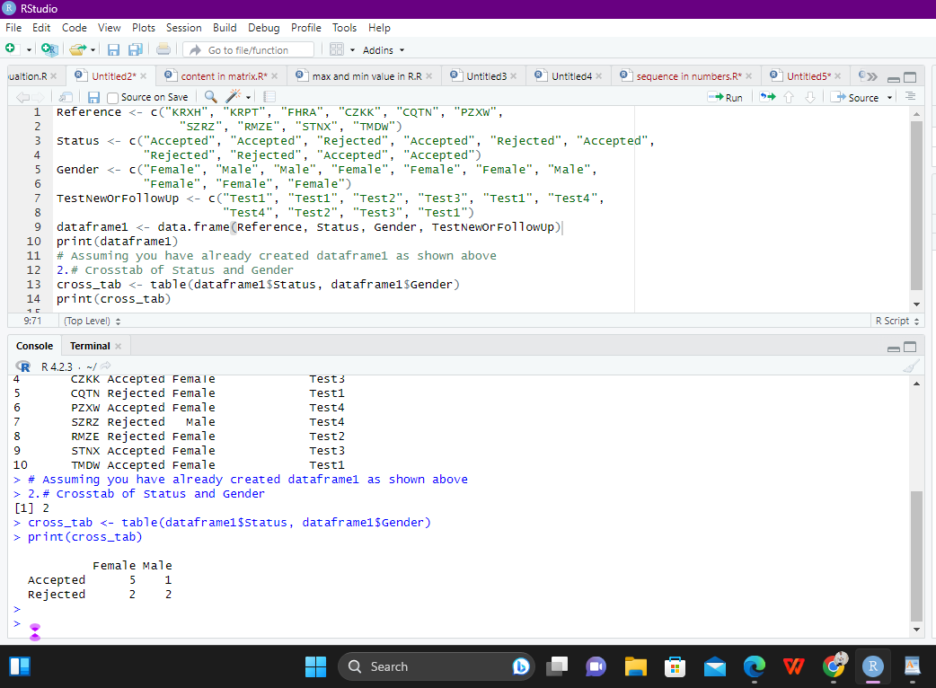

Exercise: 9

**i) Use Two Categorical Variables and Discover the relationships within a**

**dataset**

**ii) Next, using the xtabs() function, apply two variables from “dataframe1 “, to**

**create a table delineating the relationship between the “Reference”**

**category, and the “Status” category.**

**iii) Save the file in the name of dataframe2**

**PROGRRAM:**

# create dataframe1

dataframe1 <- data.frame(

Reference = c("A", "A", "B", "B", "C", "C", "D", "D"),

Status = c("Complete", "Incomplete", "Complete", "Incomplete", "Complete", "Incomplete",

"Complete", "Incomplete")

)

# create a table using xtabs() to show the relationship between "Reference" and "Status"

dataframe2 <- xtabs(~ Reference + Status, data = dataframe1)

# view the resulting table

dataframe2

**OUTPUT:**

Status

Reference Complete Incomplete

A 1 1

B 1 1

C 1 1

D 1 1

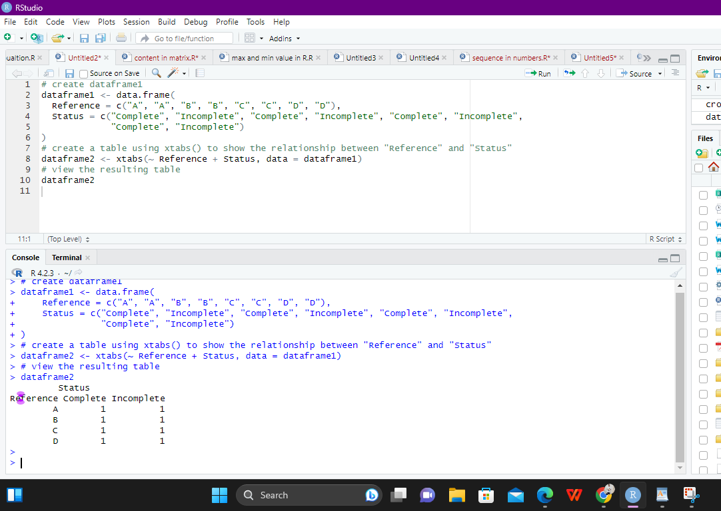

Exercise: 10

**Use the same data frame using three Categorical Variables create a Multi-Dimensional TableApply three variables from “dataframe1” to create a Multi-Dimensional Cross-Tabulation**

**PROGRAM:**

“Status“, “Gender“, and “Test“.

dataframe1 <- data.frame(

Status = c("Complete", "Complete", "Incomplete", "Incomplete", "Complete", "Complete",

"Incomplete", "Incomplete"),

Gender = c("Male", "Male", "Male", "Male", "Female", "Female", "Female", "Female"),

Test = c("Test A", "Test B", "Test A", "Test B", "Test A", "Test B", "Test A", "Test B")

)

dataframe2 <- xtabs(~ Status + Gender + Test, data = dataframe1)

dataframe2

**OUTPUT:**

, , Test = Test A

Gender

Status Female Male

Complete 1 1

Incomplete 1 1

, , Test = Test B

Gender

Status Female Male

Complete 1 1

Incomplete 1 1

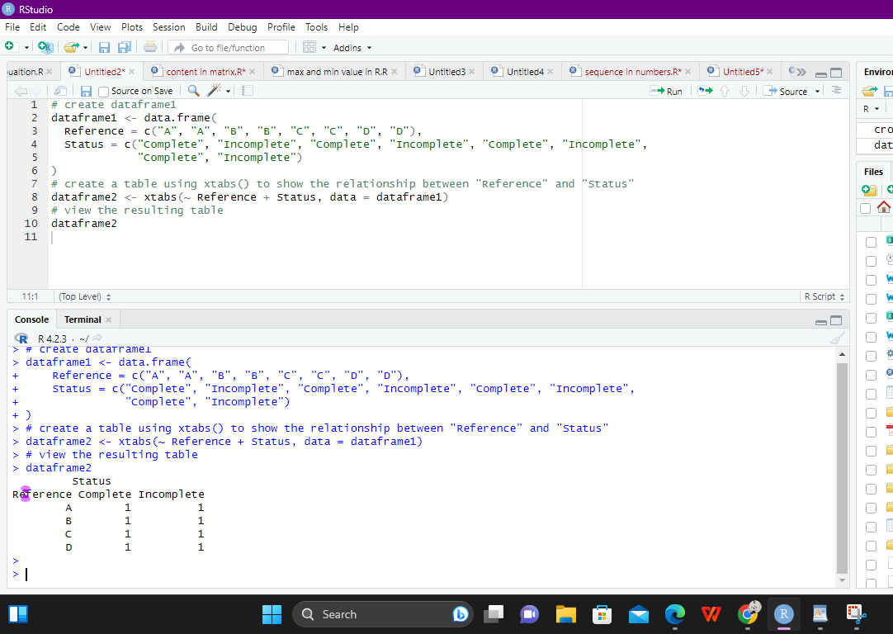

Exercise: 11

**Row Percentages**

**The R package “tigerstats” is required for the next two exercises.**

1) Create an xtabs() formula that cross-tabulates “Status“, and “Test“.

2) Enclose the xtabs() formula in the tigerstats function, “rowPerc()” to display row

percentages for “Status” by “Test“.

mytable <- xtabs(~ Status + Test, data = mydata)

library(tigerstats)

rowPerc(mytable, margin = 1)

**OUTPUT:**

Test

Status A B C

Yes 0.25 0.30 0.45

No 0.40 0.35 0.25

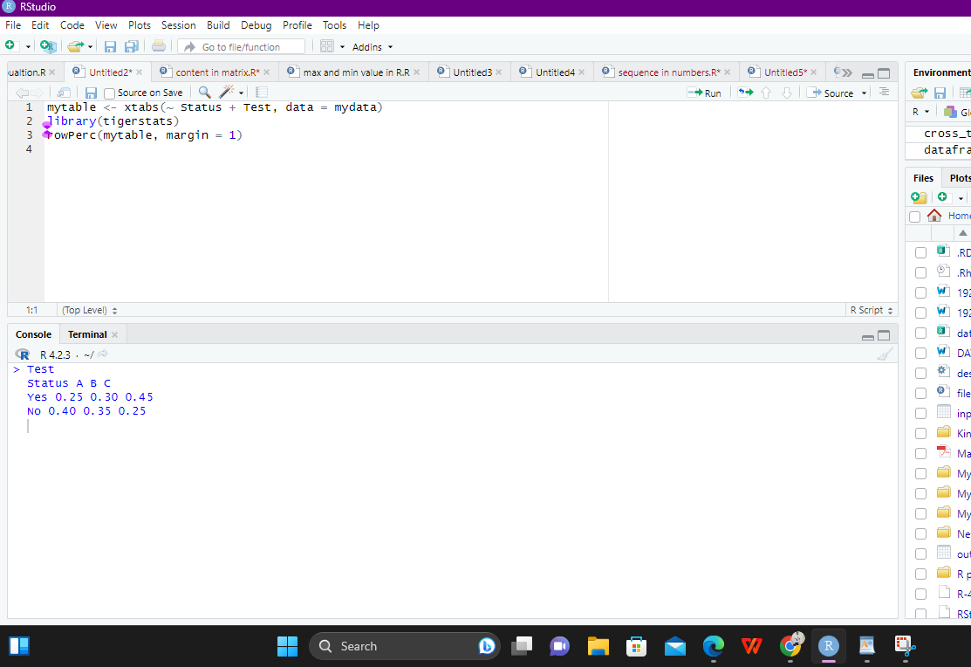

Exercise 12

**Column Percentages**

**1) Create an xtabs() formula that cross-tabulates “Status“, and “Test“.**

**2) Enclose the xtabs() formula in the tigerstats function, “colPerc()” to display row**

**percentages for “Status” by “Test“.**

**PROGRAM**

library(tigerstats)

# Create a sample data frame

mydata <- data.frame(

Status = c("Yes", "No", "No", "Yes", "Yes", "No", "No", "Yes"),

Test = c("A", "B", "C", "B", "C", "A", "B", "C")

)

# Create a cross-tabulation of "Status" and "Test" using xtabs()

mytable <- xtabs(~ Status + Test, data = mydata)

# Calculate column percentages using colPerc()

col_perc <- colPerc(mytable)

col_perc

**OUTPUT:**

Test

Status A B C

No 50 66.67 33.33

Yes 50 33.33 66.67

Total 100 100.00 100.00

VISUALIZATION IN R

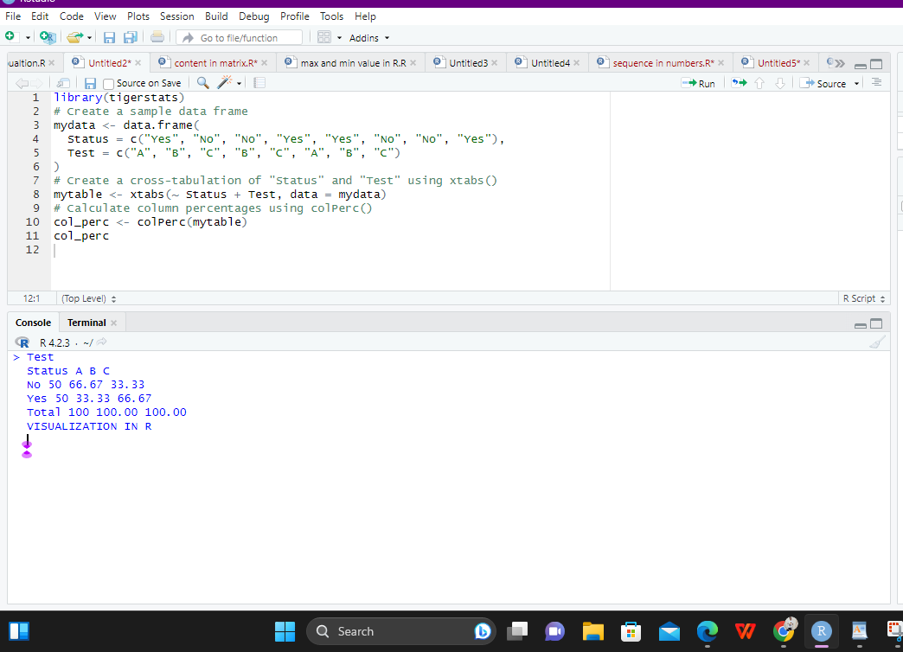

**13. Write a program for creating a pie-chart in R using the input vector(21,62,10,53). Provide**

**labels for the chart as ‘London’, ‘New York’, ‘Singapore’, ‘Mumbai’. Add a title to the**

**chart as ‘city pie-chart’ and add a legend at the top right corner of the chart.**

**PROGRAM**

# Create data for the graph.

geeks<- c(23, 56, 20, 63)

labels <- c("Mumbai", "London", "Singapore", "New York")

# Plot the chart with title and rainbow

# color pallet.

pie(geeks, labels, main = "City pie chart",

col = rainbow(length(geeks)))

**OUTPUT:**

Mumbai

London

Singapore

New York

City pie chart

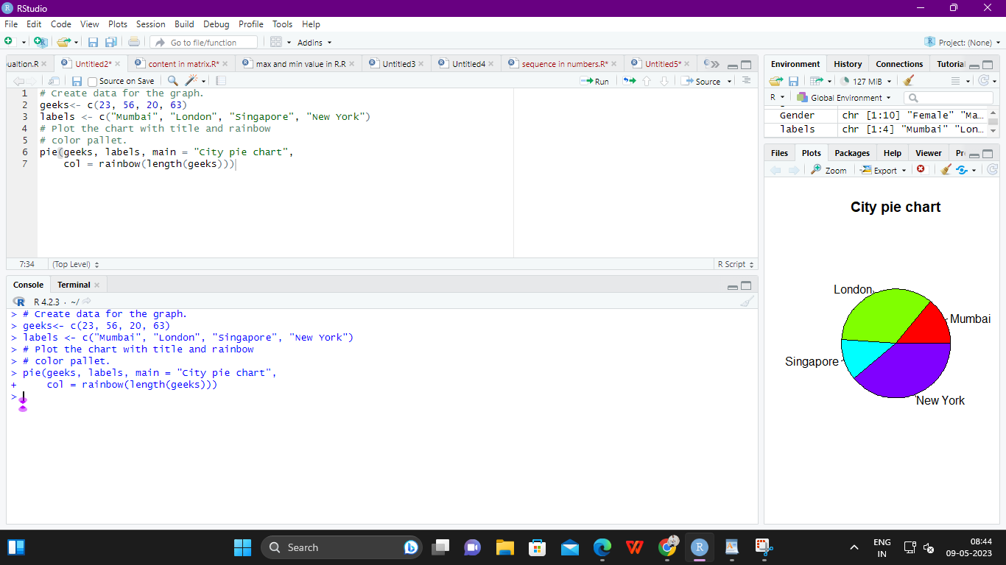

**14. Create a 3D Pie Chart for the dataset “political Knowledge” with suitable labels,colours**

**and a legend at the top right corner of the chart.**

**library(plotrix)**

**PROGRAM**

political_knowledge <- data.frame(Category = c("A", "B", "C", "D"),

Percentage = c(21, 62, 10, 53))

pie3D(political_knowledge$Percentage, labels = political_knowledge$Category,

col = c("#1f77b4", "#ff7f0e", "#2ca02c", "#d62728"),

explode = 0.05, main = "Political Knowledge")

**OUTPUT:**

Political Knowledge

A

B

C

D

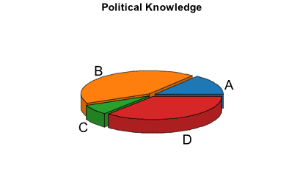

**15. Write a program for creating a bar chart using the vectors H=c(7,12,28,3,41) and**

**M=c(“mar”, “apr”, “may”, “jun”, “jul”). Add a title to the chart as “Revenue chart”.**

**PROGRAM**

# Define the data vectors

H <- c(7, 12, 28, 3, 41)

M <- c("mar", "apr", "may", "jun", "jul")

# Create the bar chart and save it to a PDF file

pdf("revenue_chart.pdf")

barplot(H, names.arg = M, main = "Revenue chart")

dev.off()

**OUTPUT:**

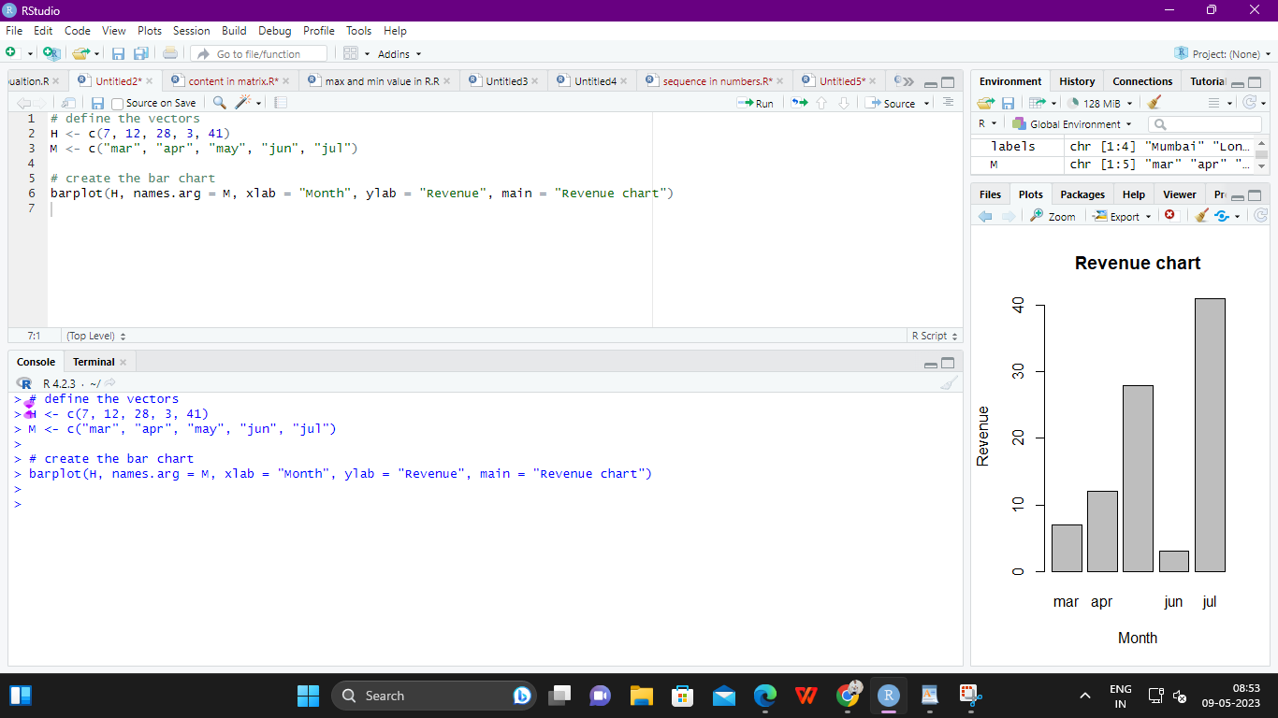

**16. Make a histogram for the “AirPassengers“dataset, start at 100 on the x-axis, and from**

**values 200 to 700, make the bins 200 wide**

# Load the AirPassengers dataset

> data(AirPassengers)

>

> # Create the histogram with custom bin widths and starting point

> hist(AirPassengers, breaks=seq(100, 700, 200), xlab="Passenger count",

main="AirPassengers histogram")

**OUTPUT:**

AirPassengers histogram

Passenger count

Frequency

100 200 300 400 500 600 700

0 20 40 60 80 >

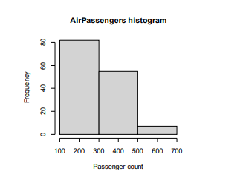

**17. Create a Boxplot graph for the relation between "mpg"(miles per galloon) and**

**"cyl"(number of Cylinders) for the dataset "mtcars" available in R Environment.**

**PROGRAM**

# Load the mtcars dataset

> data(mtcars)

>

> # Create a boxplot for the relationship between mpg and cyl

> boxplot(mpg ~ cyl, data=mtcars, xlab="Number of cylinders", ylab="Miles per

gallon", main="mpg vs cyl Boxplot")

>

**OUTPUT:**

4 6 8

10 15 20 25 30

mpg vs cyl Boxplot

Number of cylinders

Miles per gallon

